Q.1) Why is main memory unsuitable for permanent program storage or backup purposes? Furthermore, what is the main disadvantage to storing information on a magnetic disk drive as opposed to main memory?

Answer: The main reason is capacity RAM is smaller than disk drives. The problem with this is that RAM is typically faster than a drive.

Q.2) Answer the following questions regarding interrupts in an operating system.
- What is the purpose of the interrupt vector? In other words, what advantage does it provide over a general-purpose interrupt-processing routine?
- How does an interrupt differ from a trap?
- Can traps be generated intentionally by a user program? If so, for what purpose?

Answer:
A: It allows the OS to respond to hardware interrupts. It can be more efficient and organized.
B: An interrupt are events made by outside eactions that are outside the executing program. A trap is inside the program.
C: Yes, typically as a system call like reading a file.

Q.3) Why is multi-core processing more efficient than placing each processor on its own chip?

Answer: Communication between cores is easier

Q.4) Suppose we want to start a new process on a UNIX system and load a program into it. Which system calls must be executed by a command interpreter or shell to achieve that?

Answer: fork() exec()

Q.5) 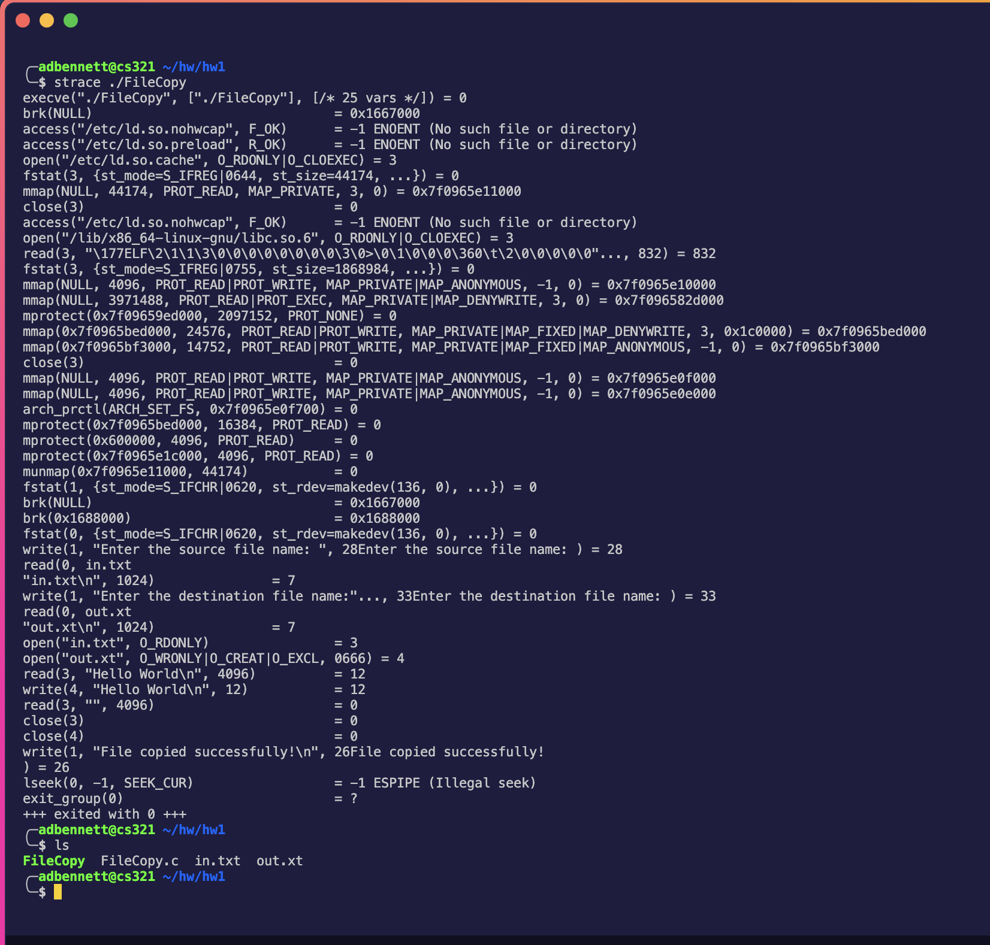
Q.6)
a.)
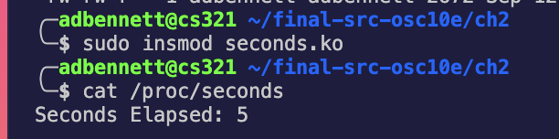
b.) 

